MiSACWIS Project

CM03 – Maintain Case Information Screen Specification

Version 2.16

November 18, 2015

Prepared for:


120 N. Washington Square
SACWIS Project, 3rd Floor
Lansing, MI 48933

Prepared by:

Revision Log
Version | Date | A/D/C (Add, Delete, Change) | Author | Document Section # | Description
0.1 | 08/22/2011 | A | N Page |  | Initial version
0.2 | 08/26/2011 | C | N Page | 3.1.2 | Corrected rows
0.3 | 08/26/2011 | C | S Kulkarni | 3.1.2 | Added To Be Screens
0.4 | 08/29/2011 | C | N Page | 2.2  3.2.3 | Cleaned up Business Rules
0.5 | 08/30/2011 | C | N Page
0.6 | 08/31/2011 | C | S Kulkarni | 3.2.3 | Cleaned up Business Rules
0.7 | 09/01/2011 | C | N Page |  | Removed Screen Field rows to be deleted
0.8 | 09/02/2011 | C | N Page |  | Field Grid updates
0.9 | 09/06/2011 | C | S Kulkarni  N Page | 3.2.2 | Added a To Be and updated Field Grid  Field Grid updates
0.10 | 09/07/2011 | C | N Page | 3.2.2, 3.2.4 | Remove ‘delete’ hyperlink from Case Members tab
0.11 | 09/08/2011 | C | N Page | 3.5.2  3.2.2  3.3, 3.4 | Added To Be screen  Added HH (58913)
1.0 | 09/08/2011 | A | N Page |  | Approved
1.1 | 09/08/2011 | C | S Kulkarni |  | QA Approved
1.2 | 09/16/2011 | C | N Page | 3.2.2, 3.2.3, 3.6.2, 3.6.3, 3.6.4, 3.6.5 | Updated based on Change Control #
1.3 | 09/19/2011 | C | N Page | 3.6.2 | Updates based on 9/16 meeting
1.4 | 09/20/2011 | C | N Page | 3.6.5 | Added BR regarding Copy
1.5 | 09/22/2011 | C | S Kulkarni |  | Field Grids Updated  TOC
1.6 | 11/11/2011 | C | N Page | 1 | Updated Purpose
1.7 | 11/12/2011 | C | N Page | 3.2.5.3 | Change Control #:1513. 2295  Quality Assurance Review. No functionality impact.
1.8 | 11/17/2011 | C | S Kulkarni  N Page | 3.1.3  3.4.1  3.4.7, 3.5.8 | Change Control #:1513  Quality Assurance Review. No functionality impact.  New To Be screen – replace “OK” button with Apply, Save  Ref vals added
1.9 | 11/29/2011 | C | N Page | 3.1.2  3.1.4 | Change Control # 2088  Remove references to “Unlink” functionality
1.10 | 12/12/2011 | C | N Page | 1, 3.1.2, 3.1.3, 3.1.4 | Change Control #2215  Add Responsible County
1.11 | 12/13/2011 | C | N Page | 3.1.3, 3.3.3, 3.4.4 | Change Control # 2289  Correct Field Grid – Disposition Category
1.12 | 12/28/2011 | C | N Page | 3.3.1,, 3.3.3 | Change Control #2533  Change Control #1579  Add Apply Save Cancel to screen
1.13 | 12/29/2011 | C | N Page |  | Approved  All revisions accepted
1.14 | 01/10/2012 | C | N Page | 3.1.2, 3.1.4  2.2 | Change Control #2689  Req 58722 Put ‘unlink’ hyperlink back in  Change Control #2296  Remove BR 2.2.1
1.15 | 01/16/2012 | C | N Page | 2.3 | Change Control #2808  Security grid
1.16 | 01/24.2012 | C | N Page | 3.6.8 | Change Control # 1579, 2196
1.17 | 01/26/2012 | C | Sangeetha Rajan | Many | Change Control #1579
2.0 | 04/09/2012 | C | N Page | 3.1.2, 3.1.3, 3.2.4  3.5.4, | Change Control #7015  Resp Cnty – Region + buttons
2.1 | 04/19/2012 | C | N Page | 3.2.2, 3.2.4, 3.2.5.16 | Change Control # 7187
2.2 | 04/23/2012 | C | N Page | 3.2.5 | Change Control #7231
2.3 | 08/24/2012 | C | N Page |  | Change Control #16413
2.4 | 10/05/2012 | C | P. Rasher | 3.2.5 BR 16 | CC#18673 no IIR for Pilot
2.5 | 09/03/2013 | C, A | P. Rasher | 3.2.5 BR 16, 18 | CC#42946 Error handling when RID request to Bridges is Denied
2.6 | 12/12/2013 | A,C,D | Samaad Seales | 3.3.4, 3.4.4 BR 9, 12 | CC#49951
2.7 | 06/18/2014 | C | Samaad Seales | 3.3.2, 3.4.2 | CC#51134 Added the person id to the households tab and household details screens.
2.8 | 06/19/2015 | A | Joe Hart | 3.2.5#19 | CC# 88932 Update program type history Case Participant ID when CRP changes.
2.9 | 06/30/2014 | C | Samaad Seales | 3.3.1, 3.4.1 | CC#51134 To Be Screenshot updated
2.10 | 07/30/2014 | A, C | Robert LaBarre | 3.2.2, 3.2.3, 3.2.5 BR #s 16, 20 | CC#59131 Modified Members tab and business rules to account for requesting Bridges Recipient IDs for persons with no SSN (manual) or with SSN (automatic)
2.11 | 12/03/2014 |  | John Kelly |  | Accepted All Track Changes
2.12 | 01/14/2015 | C | Mark Van Hoose | 3.1.4 | JJ User Story # 90, Sprint 7
2.13 | 02/11/2015 | C | Mark Van Hoose | 3.2.3 | JJIMS Sprint 3R – Story 98
2.14 | 08/18/2015 | A,C | Joe Hart | 3.4.1  3.4.2  3.4.3  3.4.4 BR#13 – 20  3.7 | CC#83829  -Addition to S04  -Additions and modifications to Screen Fields  -New hyperlink  -New Business Rules #13 through #20  -Entirely new screen S07 in 3.7 and correlating subfields.
2.15 | 08/31/2015 | A | Joe Hart | 3.4.4 BR#17 | Additional business rule under CC#83829.  See business rule #17
2.16 | 11/18/2015 | D | J. Hart | 3.1.4  3.1.5 BR#7, 8 | CC#99498 removed Unlink hyperlink and two related business rules.
Table of Contents
1 Introduction 8
1.1 Purpose 8
1.2 Scope 8
2 Use Case Details 9
2.1 Action Buttons/Hyperlinks 9
2.2 Business Rules 10
2.3 Security Requirements 11
2.4 Screen Navigation 12
2.5 Tab Order 12
2.6 Pre-Conditions 12
2.7 Ticklers 13
2.8 Notifications 13
2.9 Calendar 13
2.10 Reports 14
2.11 Notes and Assumptions 14
3 Screen Details 15
3.1 Case Information 15
3.1.1 As Is – Case Detail Tab 15
3.1.2 To Be – Case Detail Tab Mock Up 16
3.1.3 Screen Fields 17
3.1.4 Action Buttons/Hyperlinks 21
3.1.5 Business Rules 22
3.1.6 Screen Navigation 24
3.1.7 Pre-Conditions 24
3.1.8 Reference Values 24
3.2 Members Tab 25
3.2.1 As Is – Members Tab 25
3.2.2 To Be – Members Tab 26
3.2.3 Screen Fields 27
3.2.4 Action Buttons/Hyperlinks 33
3.2.5 Business Rules 34
3.2.6 Screen Navigation 39
3.2.7 Pre-Conditions 39
3.2.8 Reference Values 39
3.3 Households Tab 40
3.3.1 To Be – Households Tab Mock Up 40
3.3.2 Screen Fields 41
3.3.3 Action Buttons/Hyperlinks 44
3.3.4 Business Rules 45
3.3.5 Screen Navigation 47
3.3.6 Pre-Conditions 47
3.3.7 Reference Values 47
3.4 Household Details 48
3.4.1 To Be – Household Details Mock Up 48
3.4.2 Screen Fields 49
3.4.3 Action Buttons/Hyperlinks 52
3.4.4 Business Rules 52
3.4.5 Screen Navigation 55
3.4.6 Pre-Conditions 55
3.4.7 Reference Values 56
3.5 Relationships Tab 58
3.5.1 As Is – Relationships Tab 58
3.5.2 To Be – Relationships Tab Mock Up 59
3.5.3 Screen Fields for Relationship Screen (1 of 2) 60
3.5.4 Action Buttons/Hyperlink 64
3.5.5 Business Rules 65
3.5.6 Screen Navigation 66
3.5.7 Pre-Conditions 66
3.5.8 Reference Values 66
3.6 Associated Persons Tab 68
3.6.1 As Is – Associated Persons Tab 68
3.6.2 To Be – Associated Persons Tab 69
3.6.3 Screen Fields 70
3.6.4 Action Buttons/Hyperlinks 77
3.6.5 Business Rules 77
3.6.6 Screen Navigation 78
3.6.7 Pre-Conditions 78
3.6.8 Reference Values 78

List of Figures
Figure 1 – As Is - Case Detail Tab 15
Figure 2 – To Be – Case Detail Tab 16
Figure 3 – As Is - Members Tab 25
Figure 4 – To Be –Members Tab 26
Figure 5 - To Be – Households Tab Mock Up 40
Figure 6 – To Be – Household Details Mock Up 48
Figure 7 – As Is – Relationship Tab 58
Figure 8 – To Be – Relationship Tab 59
Figure 9 – As Is - Associated Persons Tab 68
Figure 10 – To Be – Associated Persons Tab 69

Introduction

Purpose
The CM03 - Maintain Case use case is called from the “View Case Information” hyperlink on the Case Overview page, which is accessed from the Case navigation pane. The CM03 - Maintain Case use case provides the user with access to basic case information, which is represented by five pages. The five tabs are:
- Case Detail: The Case Detail page displays a grid of the history of Responsible County/Organization for the case. The worker can use the “Add Responsible County” button to add an entry to the Responsible Country/Organization List. The Case Detail page also includes a grid of Intakes and Investigations that have been linked to the Case record. And this page also displays Case Reference information such as legacy system values or case specific identifiers that can be used by users in the Case Search process, or by MiSACWIS in interface transactions such as Bridges or MiSCES.
- Members: The Members page presents a list of all active case members along with basic demographic details such as person name, birth date and gender. Case members that are no longer active members of the case record can be viewed via the “Case Member History” hyperlink.
- Households: The Household page allows authorized users to view as well as configure multiple households for each case. The information captured by users on this page serves as a basis for service planning.
- Relationships: The Relationships page provides user access to viewing and defining relationships between case members. As users define one case member’s relationship to another case member, MiSACWIS simultaneously defines reciprocal relationship between the two individuals as well as determining relationships between other case members.
  - Associated Persons: The Associated Persons page allows users the ability to associate/view people who have been defined as significant to the case and the case members, but are not active members of the case. Associated Persons typically include people such as attorneys, Indian custodians, teachers or therapists.

Scope
This Use Case covers the processes used to view Case details, members, relationships, and associated persons on the Case information page in MiSACWIS.

Use Case Details

Action Buttons/Hyperlinks
Status (Keep/Add/  Modify/Delete) | Label | Type | On Click Action/Navigation
Keep | Apply | Button | System performs validation on entered values.  If no errors are found system saves values.  If errors are found appropriate message is displayed.  User remains on the same page.
Keep | Save | Button | System performs validation on entered values.  If no errors are found system saves values.  If errors are found appropriate message is displayed.  User is returned to prior page.
Keep | Cancel | Button | All entered values/ changes are ignored.  User is returned to prior page.
Keep | Help | Hyperlink | Screen level Help appears in a separate browser window.

Business Rules
No. | Status (Keep/Add/Modify/Delete) | Business Rule Description | Modified Business Rule Description | Execution Event (field tab out/save etc) | Error Msg Code  To be completed by Development Team
1 | Add | Only workers assigned to the Case in focus can create and update the following records for the Case in focus: Member, Household, Relationship, Association
2 | Add | Any DHS workers but only Assigned non-DHS workers can read the following case information for the Case in focus: Member, Household, Relationship, Association.
3 | Modify | When a person is made Inactive on a case due to drop down option “Death”, that person’s status will show as “Inactive” in View Member History grid. | When a person is made Inactive on a case due to drop down option “Death”, that person’s status will show as “Deceased” in View Member History grid.
4 | Add | Only Supervisors can update Closed Cases

Security Requirements
No. | Status (Keep/Add/  Modify/Delete) | Security Requirement
1 | Keep | Create  Foster Care Worker
2 | Keep | Read  Worker
3 | Keep | Update  Foster Care Worker; Supervisor
4 | Keep | Delete  N/A

Screen Navigation
No. | Status (Keep/Add/  Modify/Delete) | To Screen Navigation Path
1 | Keep | View case information from CM02- View Case Overview

Tab Order
No. | Status (Keep/Add/  Modify/Delete) | Screen name
1 | Keep | Case Detail
2 | Keep | Members
3 | Add | Households
4 | Keep | Relationships
5 | Keep | Associated Persons

Pre-Conditions
No. | Status (Keep/Add/Modify/Delete) | Pre-Condition
1 | N/A

Ticklers
Status (Keep/Add/Modify/Delete) | Tickler Name | Trigger Action | Tickler Generation Business Rule & Description | Tickler Removal Business Rule | Tickler Text
Status (Keep/Add/Modify/Delete) | Tickler Role
 | N/A

Notifications
Status (Keep/Add/Modify/Delete) | Notification Name | Trigger Action | Message Business Rule & Description | Message Text
Status (Keep/Add/Modify/Delete) | Notification Role | Trigger Action | Message Business Rule & Description | Message Text
 | N/A

Calendar
Status (Keep/Add/Modify/Delete) | Calendar Name | Trigger Action | Calendar Event Generation Business Rule & Description | Calendar Event Date and Time Business Rule | Calendar Event Text
Status (Keep/Add/Modify/Delete) | Calendar Role
 | N/A

Reports

Notes and Assumptions
Households: Households created by CPS (navigating to Household functionality from Investigative Tasks) must not impact Households created by Foster Care (navigated to from within the Ongoing Case).
- Investigation Tasks will include a link to Household functionality.
- If one or more Households are defined from Investigation Topics then, if the Case did not already have one or more Households defined, the Investigation Household(s) would be pulled into the Case
- If one or more Households are defined from Investigation Topics then, if the Case already has one or more Households defined these would remain unchanged.)
Households created from Investigative Tasks will not be visible from those created in Ongoing Case and and vise versa.

Screen Details

Case Information

As Is – Case Detail Tab
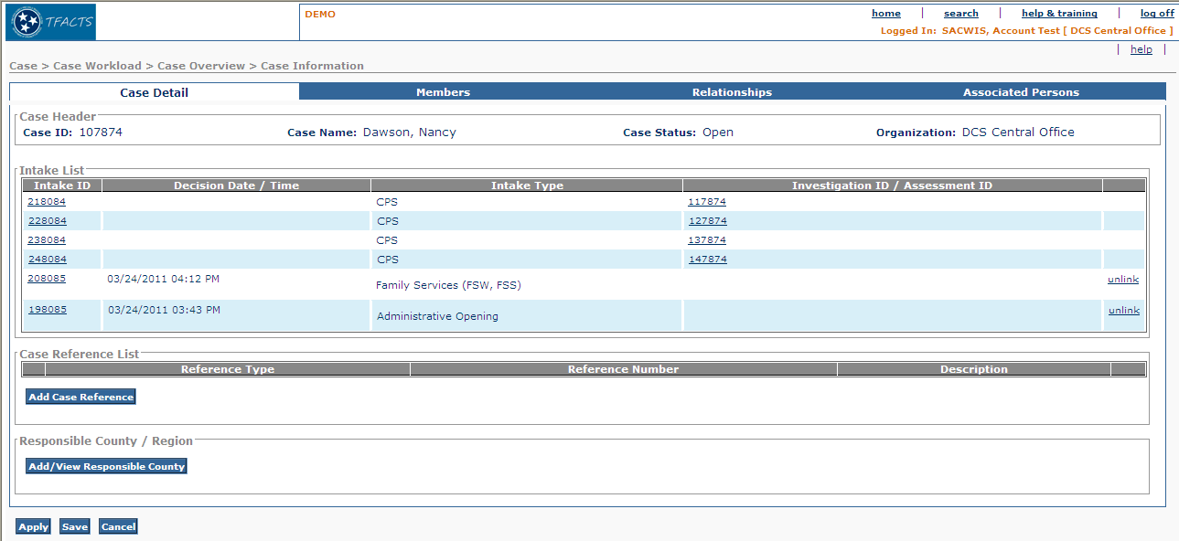
Figure 1 – As Is - Case Detail Tab

To Be – Case Detail Tab Mock Up
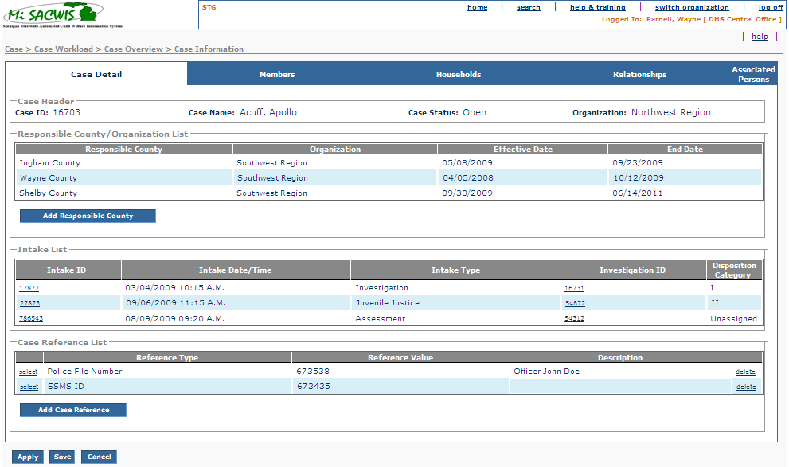
Figure 2 – To Be – Case Detail Tab

Screen Fields
Status (Unchanged/Add/Modify/Delete) | As Is Class.Attribute Name | To Be Class.Attribute Name | As Is Display Name | To Be Display Name | To Be Type | To Be Align | To Be Size | To Be Read Only | To Be Calculation | To Be Edit Mask | To Be UI Validation
Keep | N/A | N/A | Case Header | Case Header | Section Header | L | N/A | T
Keep | CaseBase.case_id | CaseBase.case_id | Case ID | Case ID | Display Text | L | 22 | T
Keep | CaseBase.caseLastName + CaseBase.CaseSuffixNameCode  + CaseBase.caseFirstName + CaseBase.caseMiddleName | CaseBase.caseLastName + CaseBase.CaseSuffixNameCode  + CaseBase.caseFirstName + CaseBase.caseMiddleName | Case Name | Case Name | Display Text | C | N/A | T |  | Last name, first name, middle name of case reference person
Keep | CaseStatus.caseStatusCode | CaseStatus.caseStatusCode | Case Status | Case Status | Text Field | C | N/A | T | System derived from Case Status where CaseStatus.end_eff_date is null  Use short desc from Ref Data where domain code=’CaseStatus’
Keep | Agency.agencyName | Agency.agencyName | Organization | Organization | Text Field | R | 100 | T | System derived  From CaseAgencyLink.caseAgencyLinkId where end date is null
Add | N/A | N/A | N/A | Responsible County/Organization List | Section Header | L | N/A | T |  |  | N/A
Add | N/A | CaseAgencyLink.countyCode | N/A | Responsible County | Display Text | L | 100 | T
Add | N/A | CaseAgencyLink.Organization | N/A | Organization | Display Text | L | 100 | T
Add | N/A | CaseAgencyLink.beginEffDate | N/A | Effective Date | Display Text | L | 30 | T
Add | N/A | CaseAgencyLink.endEffDate | N/A | End Date | Display Text | L | 30 | T
Keep | N/A | N/A | Intake List | Intake List | Section Header | L | N/A | T |  |  | N/A
Keep | Intake.intakeId | Intake.intakeId | Intake ID | Intake ID | Hyperlink | L | 22 | T
Modify | Intake.DecisionDate | Intake.DecisionDate | Decision Date / Time | Intake Date / Time | Display Field | L | 25 | T |  | mm/dd/yy hh:mi AM ET
Keep | IntakeType.intakeTypeCode | IntakeType.intakeTypeCode | Intake Type | Intake Type | Label | L | 30 | T
Modify | caseBase.CaseId | caseBase.CaseId | Investigation ID/Assessment ID | Investigation ID | Hyperlink | L | 22 | T
Add | N/A | INVESTIGATION.dispositionDecision | N/A | Disposition Category | Display Textl | L | 100 | T
Keep | N/A | N/A | Case Reference List | Case Reference List | Label | L |  | T
Keep | CaseReference.caseReferenceTypeCode | CaseReference.caseReferenceTypeCode | Reference Type | Reference Type | Display Text | L | 30 | T
Modify | CaseReference.caseReference Nbr | CaseReference.caseReferenceNbr | Reference Number | Reference Value | Number | L | 22 | T
Keep | CaseReference.otherCaseReferenceDesc | CaseReference.otherCaseReferenceDesc | Description | Description | Display Text | L | 60 | T

Action Buttons/Hyperlinks
status (Keep/Add/Modify/Delete) | Label | Type | On Click Action/Navigation
Keep | Add Responsible County | Button | Execute IV40 – Maintain Responsible County
Keep | Intake ID | Hyperlink | Takes the user to the appropriate intake detail screen depending on the intake type (i.e. CPS, Non-CPS, JJ)
Delete | Unlink | Hyperlink | Unlink the Intake from the Case after displaying a confirmation message to user.
Modify | Investigation ID | Hyperlink | Executes IV20 – Investigation Overview(Investigation ID/Assessment ID hyperlink has been modified to Investigation ID)
Keep | Add Case Reference | Button | Execute CM03a create scenario
Keep | Select | Hyperlink | Execute CM03a view/update/modify scenario
Keep | Delete | Hyperlink | Execute CM03a Delete scenario

Business Rules

No. | Status (Keep/Add/  Modify/Delete) | Business Rule Description | Modified Business Rule Description | Execution Event (field tab out/save etc) | Error Msg Code  To be completed by Development Team
1 | Keep | The organization to be displayed on the Detail tab should be the current organization ‘case owner’ which is system derived from organization creating or reopening case; or organization to whom case has been transferred |  | On screen load or refresh
2 | Keep | Case name is displayed as Last Name, Suffix, First Name, Middle Initial (Lamb, Jr., Mary H.).  The case name always reflects the current Case Reference Person’s primary name in the order delineated above. |  | On screen load or refresh
3 | Keep | If the case is in open status, the status remains unchanged  If case is closed, the worker can view the screen and case remains closed (i.e. frozen) |  | On screen load or refresh

4 | Add | If Investigative ID is blank then Disposition Category = “Unassigned”
5 | Modify | The Intake List should display by Investigation ID first then in reverse chronological order by Decision Date/Time with the most recent record at the top. | The Intake List should display by Investigation ID first then in reverse chronological order by Intake Date/Time with the most recent record at the top. | On screen load or refresh
6 | Keep | The sort order for the case reference list will be displayed in alphabetical order by reference type code |  | On screen load or refresh
7 | Delete | If user selects to Unlink the Intake then display a confirmation message to the user.  If user selects No then do not perform the unlink. |  | Unlink hyperlink
8 | Delete | An Intake cannot be unlinked if it has been attached to any ongoing piece or work. |  | Unlink hyperlink

Screen Navigation
No. | Status (Keep/Add/  Modify/Delete) | To Screen Navigation Path
1 | Keep | Workload > Case Id > View Case Overview

Pre-Conditions
No. | Status (Keep/Add/  Modify/Delete) | Pre-Condition
1 | Keep | Case must exist in MiSACWIS

Reference Values
No. | Status (Keep/Add/  Modify/Delete) | To Be Class Attribute | Domain Code | Short Desc | Ref Data Code
1 | N/A

Members Tab

As Is – Members Tab

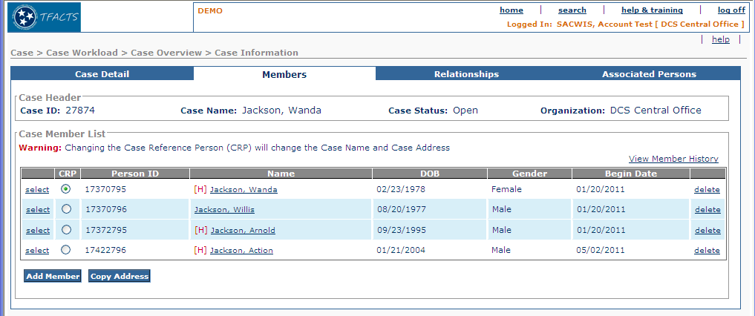
Figure 3 – As Is - Members Tab

To Be – Members Tab
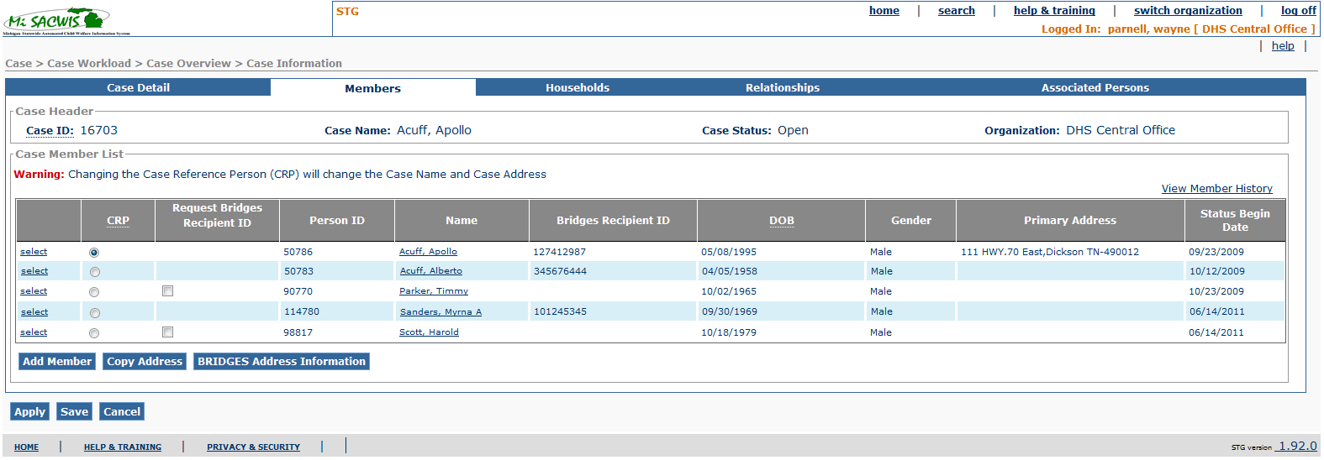
Figure 4 – To Be –Members Tab

Screen Fields
Status (Unchanged/Add/Modify/Delete) | As Is  Class.Attribute Name | To Be  Class.Attribute Name | As Is  Display Name | To Be  Display Name | To Be  Type | To Be  Align | To Be Size | To Be  Read  Only | To Be  Calculation | To Be  Edit Mask | To Be  UI Validation
Keep | N/A | N/A | Case Header | Case Header | Section Header | L | N/A | T
Keep | CaseBase.case_id | CaseBase.case_id | Case ID | Case ID | Display Text | L | 22 | T
Keep | CaseBase.caseLastName + CaseBase.CaseSuffixNameCode  + CaseBase.caseFirstName + CaseBase.caseMiddleName | CaseBase.caseLastName + CaseBase.CaseSuffixNameCode  + CaseBase.caseFirstName + CaseBase.caseMiddleName | Case Name | Case Name | Display Text | C | N/A | T |  | Last name, first name, middle name of case reference person
Keep | CaseStatus.caseStatusCode | CaseStatus.caseStatusCode | Case Status | Case Status | Text Field | C | N/A | T | System derived from Case Status where CaseStatus.end_eff_date is null  Use short desc from Ref Data where domain code=’CaseStatus’
Keep | Agency.agencyName | Agency.agencyName | Organization | Organization | Text Field | R | 100 | T | System derived  From CaseAgencyLink.caseAgencyLinkId where end date is null
Keep | N/A | N/A | Case Member List | Case Member List | Section Header | L | N/A | T
Keep | N/A | N/A | Warning: Changing the Case Reference Person (CRP) will change the Case Name and Case Address | Warning: Changing the Case Reference Person (CRP) will change the Case Name and Case Address | Display Text | L | N/A | T
Keep | CaseParticipant.referencePersonFlag | CaseParticipant.referencePersonFlag | CRP | CRP | Radio Button | L | 22 | F |  |  | User selected
Add | N/A | N/A | N/A | Request Bridges Recipient ID | Checkbox | L | 2 | F | Display a checkbox next to any person who does not have a Bridges Recipient ID associated with them in the PersonReference table and does NOT have an SSN in their person profile.  Reference BR #19 for processing checked persons on Apply/Save |  | User selected
Keep | CaseParticipant.personID | CaseParticipant.personID | Person ID | Person ID | Display Text | L | 22 | T
Keep | Person.LastName + Person.suffixNameCode + Person.FirstName + Person.middleName | Person.LastName + Person.suffixNameCode + Person.FirstName + Person.middleName | Name | Name | Display  Text | L | 100 | T | Use CaseParticipant.personID  Last name, first name, middle name
Add | N/A | PersonReference.personRefNbr | N/A | Bridges Recipient ID | Display Text | L | 30 | T | Based on the PersonReference record for the Person in focus where personRefTypeCode = ‘RECIPIENTID’
Keep | Person.birthdate | Person.birthdate | DOB | DOB | Display Text |  | 10 | T | MM/DD/YYYY
Keep | Person.genderCode | Person.genderCode | Gender | Gender | Display Text | R | 30 | T | Use short desc.from Ref. Data where Domain Category=’Gender’
Add | N/A | Address.streetNbr + Address.preDirectionalCode + Address.streetName + Address.streetSuffixCode + Address.postDirectionalCode + Address.UnitNameCode + Address.UnitNumber + Address.CityName + Address.stateCode + Address.zip5Code + Address.zip4Code +  Address.tribalReservationFlag | N/A | Primary Address | Display Text | L | N/A | T | Use  CaseParticipant.CaseParticipantId
Modify | CaseParticipantStatus.beginEffDate | CaseParticipantStatus.beginEffDate | Begin Date | Status Begin Date | Date Field | L | 10 | T | MM/DD/YYYY

Action Buttons/Hyperlinks
Status (Keep/Add/Modify/Delete) | Label | Type | On Click Action/Navigation | Tab Order
Keep | View Member History | Hyperlink | Executes CM03b view scenario (CM03b-S02) | N/A
Keep | Select | Hyperlink | Executes CM03b create/update scenario (CM03b-S01) | N/A
Delete | Delete | Hyperlink | Executes CM03b delete scenario | N/A
Keep | (Name) | Hyperlink | Execute PM01i – S01 in view mode | N/A
Keep | Add Member | Button | Executes CF54 – Find a Person  Once person is selected, if person has no Recipient ID then executes IF902a – Exchange Information with Bridges (MCI-Person Data) interface to create one.  See BR 3.2.5.16 | N/A
Keep | Copy Address | Button | Executes CF53a – Copy Primary Address Information. Button is always enabled | N/A
Add | BRIDGES Address Information | Button | Executes IF902a – Exchange Information with Bridges (MCI-Person Data) screen 1 (view only) | N/A
Keep | Apply | Button | Save all data to database and remain on page | N/A
Keep | Save | Button | System performs validation on entered values.  If no errors are found system saves values.  If errors are found appropriate message is displayed.  User is returned to prior page. | N/A
Keep | Cancel | Button | All entered values/ changes are ignored.  User is returned to prior page. | N/A

Business Rules
No. | Status (Keep/Add/Modify/Delete) | Business Rule Description | Modified Business Rules | Execution Event (field tab out/save etc) | Error Msg Code  To be completed by Development Team
1 | Keep | The organization to be displayed on the Members tab should be the current organization ‘case owner’ which is system derived from organization creating or reopening case; or organization to whom case has been transferred |  | On screen load or refresh
2 | Keep | Case name is displayed as Last Name, Suffix, First Name, Middle Initial (Lamb, Jr., Mary H.)  The case name always reflects the current Case Reference Person’s primary name in the order delineated above. |  | On screen load or refresh
3 | Keep | Status is not modifiable from any action performed in this screen.
4 | Delete | A case member cannot be deleted if the member is associated with any pieces of work associated with this case.  Message is displayed when user tries to delete a case member that is associated with any pieces of work, the following message is displayed.  “This person is associated with MiSACWIS work tasks within this case. You cannot delete this person.” |  | Delete Hyperlink
5 | Keep | If a user tries to add a person to the case member list that is already a member of that case, the system should display an error message:  “This person is already a case member and cannot be added again.” |  | Add member Button
6 | Delete  (“Delete” functionality replaced by “Deactivate”. This is found in CM03b-Maintain Case Member Information) | Message is displayed when user selects a case member to delete “This person may be active in the following TFACTS work tasks, you cannot delete the person.” |  | At “Delete Hyperlink”
7 | Keep | Members will display in order on the current member page in date of birth order, from the oldest to the youngest. Secondary sort will be in alpha order by last name, then first name. |  | On screen load or Refresh
8 | Keep | Members with no DOB will display at the bottom of the list. Secondary sort will be in alpha order by last name; first name.
9 | Keep | The system must provide the ability to add new case participants at any time for an open case |  | Add Member Button
10 | Keep | There can be only one Case Reference Person (CRP) per case at any given time.
11 | Delete | A person can only be a Reference person for one case at a time.  Example: ("IE John Doe cannot be the CRP in case 12345, and case 23456 at the same time")
12 | Keep | When adding case members the case member person will always be an established person (i.e. will exist in MiSACIWS database).
13 | Keep | When no CRP information is stored then default the radio button to the first case member on the list.
14 | Modify | A CRP can be the same in an adoption and Non-adoption case | A CRP can be the same in a Permanent Ward case and a Non Permanent Ward case
15 | Keep | When in an edit flow and the name hyperlink is clicked, the system shall present the user with a save and proceed confirmation message. |  | On Click of Name Hyperlink
16 | Add | When the user adds a new case member, on save, MiSACWIS will determine if a Bridges Recipient ID exists for the Case Member. If yes, the system will save newly entered or modified information as usual.  If no Bridges Recipient ID exists for the person but they do have an SSN in their person profile or a Person Reference value of ‘HISTORICALSSN’, as a part of the save action, the system will send a request for a Bridges Recipient ID passing the SSN or HISTORICALSSN value as the ‘SSN’ and generate insert into the Person Reference table for the person missing a Bridges Recipient ID using the following mapping:  Person Reference ID = System Generated ID  Person Ref Type Code = Temporary Recipient ID  Person Ref Number = Use the InvestigationPerson.personID  Audit Details - Current Sysdate and Current Logged-In Security User ID  If Bridges returns an error that a Bridges Recipient ID already exists for this SSN, a message should be displayed to the user informing them of this but the system will still save the case member without adding the Bridges Recipient ID person reference value.  If no Bridges Recipient ID exists for the person and they do NOT have an SSN in their person profile or a Person Reference value of ‘HISTORICALSSN’, the system will save the newly entered or modified information as usual without requesting the Bridges Recipient ID. |  | Apply/Save
17 | Add | BRIDGES detail hyperlink executes IF902a – Exchange Information with Bridges (MCI-Person Data) screen 1 (view only)  Pass the Primary address of the Case Member in the Row selected.
18 | Add | For each request to the IF902a web service to retrieve a Bridges/Recipient Id (see 3.4.5 BR#16), display the error code/message received from Bridges if the error code is not equal to 0. Do not allow the Apply/Save when the error code is not equal to 0. |  | Apply/Save
19 | Add | When the CRP is changed to a different case participant, update the case participant id field in any open CPS, Guardianship, and Prevention program type history record to the case participant id of the new CRP. |  | Apply/Save
20 | Add | On apply or save of the Case Member screen, a request to generate a Bridges Recipient ID will be sent for all active Case Members whose ‘Request Bridges Recipient ID’ checkbox is checked. If those persons have a Person Reference value of ‘HISTORICALSSN’ that value will be used to populate the SSN for the associated record in the request. The request should also automatically include any active Case Members that have an SSN in their person profile but no Bridges Recipient ID.  The system will then generate inserts into the Person Reference table for the individual(s) missing a Bridges Recipient ID using the following mapping:  Person Reference ID = System Generated ID  Person Ref Type Code = Temporary Recipient ID  Person Ref Number = Use the InvestigationPerson.personID  Audit Details - Current Sysdate and Current Logged-In Security User ID  If Bridges returns any errors that a Bridges Recipient ID already exists for an SSN in the request, a message should be displayed to the user informing them of this. |  | Apply/Save

Screen Navigation
No. | Status (Keep/Add/  Modify/Delete) | To Screen Navigation Path
1 | Keep | Navigate to Case Members Page from Case Details default page (CM03-S01 or CM03-S03 or CM03-S04)

Pre-Conditions
No. | Status (Keep/Add/  Modify/Delete) | Pre-Condition
1 | Keep | Case ID must exist in MiSACWIS

Reference Values
No. | Status (Keep/Add/  Modify/Delete) | To Be Class Attribute | Domain Code | Short Desc | Ref Data Code
1 | N/A

Households Tab

To Be – Households Tab Mock Up

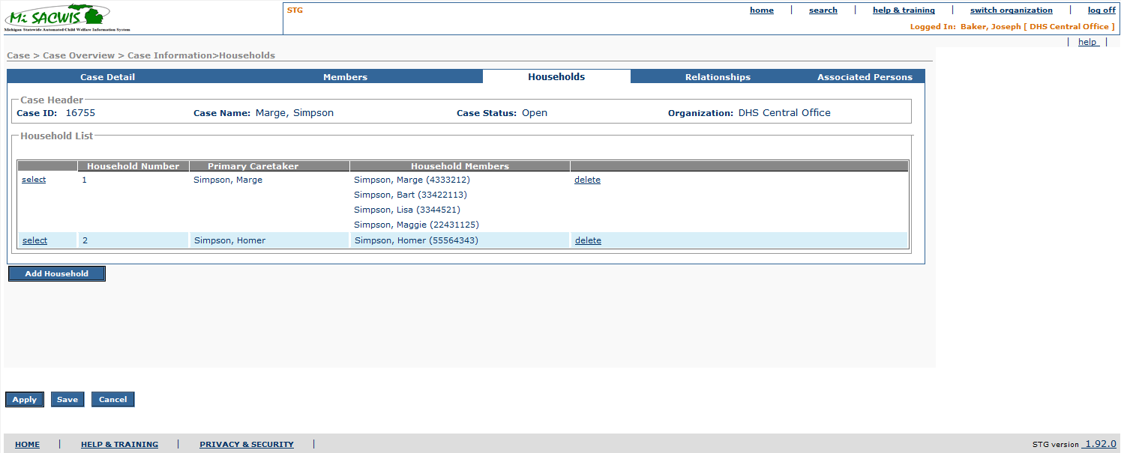

Figure 5 - To Be – Households Tab Mock Up

Screen Fields
Status (Keep/  Add/  Modify/  Delete) | As Is  Class.Attribute Name | To Be  Class.Attribute Name | As Is  Display Name | To Be  Display Name | To Be  Type | To Be  Align | To Be Size | To Be  Read  Only | To Be  Calculation | To Be  Edit Mask | To Be  UI Validation
Add | N/A | N/A | Case Header | Case Header | Section Header | L | N/A | T
Add | CaseBase.case_id | CaseBase.case_id | Case ID | Case ID | Display Text | L | 20 | T
Add | CaseBase.caseLastName + CaseBase.CaseSuffixNameCode  + CaseBase.caseFirstName + CaseBase.caseMiddleName | CaseBase.caseLastName + CaseBase.CaseSuffixNameCode  + CaseBase.caseFirstName + CaseBase.caseMiddleName | Case Name | Case Name | Display Text | C | N/A | T |  | Last name, first name, middle name of case reference person
Add | CaseStatus.caseStatusCode | CaseStatus.caseStatusCode | Case Status | Case Status | Text Field | C | N/A | T | System derived from Case Status where CaseStatus.end_eff_date is null  Use short desc from Ref Data where domain code=’CaseStatus’
Add | Agency.agencyName | Agency.agencyName | Organization | Organization | Text Field | R | 100 | T | System derived  From CaseAgencyLink.caseAgencyLinkId where end date is null
Add | N/A | N/A | N/A | Household List | Section Header | L | N/A | T
Add | N/A | Household.HouseholdNoCode | N/A | Household Number | Number | L | 22 | T
Modify | N/A | HouseholdMembers.CaseParticipant.ID where Household.householdMemberRoleCode = 'PRIMARYCARETAKER' | N/A | Primary Caretaker | Display Text | L | 110 | T | Use: CaseParticipant.personID then Person.lastName  Person.firstName (separated by comma) | Last name, first name, middle name
Modify | N/A | HouseholdMembers.CaseParticipant.ID | N/A | Household Members | Display Text | L | 110 | T | Use: CaseParticipant.personID then Person.lastName  Person.firstName (separated by comma)  Person.personID (concatenated) | Last name, first name, middle name  + Person ID (concatenated)

Action Buttons/Hyperlinks
Status (Keep/  Add/  Modify/  Delete) | Label | Type | On Click Action/Navigation
Add | Select | Hyperlink | Household Detail Page
Add | Delete | Hyperlink | Delete Household represented by the row
Add | Add Household | Hyperlink | Add Household detail page
Add | Apply | Button | System performs validation on entered values.  If no errors are found system saves values.  If errors are found appropriate message is displayed.  User remains on the same page.
Add | Save | Button | System performs validation on entered values.  If no errors are found system saves values.  If errors are found appropriate message is displayed.  User is returned to prior page.
Add | Cancel | Button | All entered values/ changes are ignored.  User is returned to prior page.

Business Rules
No. | Status (Keep/Add/  Modify/Delete) | Business Rule Description | Execution Event (field tab out/save etc) | Error Msg Code  To be completed by Development Team
1 | Add | The Households displayed will depend on how the user navigates to this screen  If the user navigates here from Investigative Tasks then only Households created from that path will be displayed.  If the user navigates here from Case Management then only the Households created from that path will be displayed.  See Section 2.11, Notes and Assumptions.
2 | Add | Households will be listed in ascending order of “Household Number”
3 | Add | Household members will be sorted: Primary Caretaker first followed by DOB – descending.
4 | Add | When the Household record has been linked to an ‘Assessment or Case Plan’, the delete hyperlink will remove display of the record from the Household page and mark the record as ‘inactive’ (Household.inactiveFlag = 1). The record will remain in the database to preserve foreign key referential integrity. Linked household records can still be modified to maintain household member information.

Screen Navigation
No. | Status (Keep/Add/  Modify/Delete) | To Screen Navigation Path
1 | Add | Case > Case Overview > Households

Pre-Conditions
No. | Status (Keep/Add/  Modify/Delete) | Pre-Condition
1 | Add | Case ID must be in MiSACWIS

Reference Values
No. | Status (Keep/Add/  Modify/Delete) | To Be Class Attribute | Domain Code | Short Desc | Ref Data Code
1 | N/A

Household Details

To Be – Household Details Mock Up

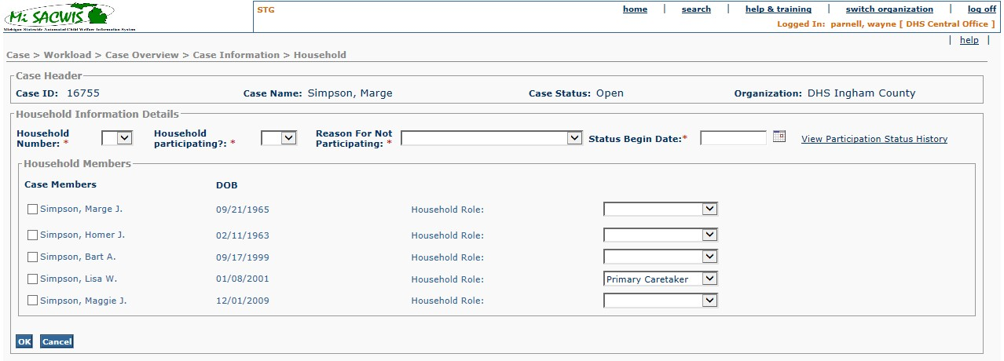

Figure 6 – To Be – Household Details Mock Up

Screen Fields
Status (Keep/  Add/  Modify/  Delete) | As Is  Class.Attribute Name | To Be  Class.Attribute Name | As Is  Display Name | To Be  Display Name | To Be  Type | To Be  Align | To Be Size | To Be  Read  Only | To Be  Calculation | To Be  Edit Mask | To Be  UI Validation
Add | N/A | N/A | Case Header | Case Header | Section Header | L | N/A | T
Add | CaseBase.case_id | CaseBase.case_id | Case ID | Case ID | Display Text | L | 20 | T
Add | CaseBase.caseLastName + CaseBase.CaseSuffixNameCode  + CaseBase.caseFirstName + CaseBase.caseMiddleName | CaseBase.caseLastName + CaseBase.CaseSuffixNameCode  + CaseBase.caseFirstName + CaseBase.caseMiddleName | Case Name | Case Name | Display Text | C | N/A | T |  | Last name, suffix, first name, middle initial
Add | CaseStatus.caseStatusCode | CaseStatus.caseStatusCode | Case Status | Case Status | Text Field | C | N/A | T | System derived from Case Status where CaseStatus.end_eff_date is null  Use short desc from Ref Data where domain code=’CaseStatus’
Add | Agency.agencyName | Agency.agencyName | Organization | Organization | Text Field | R | 100 | T | System derived  From CaseAgencyLink.caseAgencyLinkId where end date is null
Add | N/A | N/A | N/A | Household Information n Details | Section Header | L | N/A | T
Add | N/A | Household.HouseholdNoCode | N/A | Household Number | Drop Down List | L | 100 | F | DomainCode=’HouseholdNumber’ |  | User selected  Required field
Add | N/A | Household.HouseholdParticipantcode | N/A | Household participating? | Drop Down List | L | 100 | F | DomainCode=’YesNo’ |  | User selected  Required field
Add | N/A | HouseholdPrtStatus.startDate | N/A | Status Begin Date | Date Field | L | 10 | F | N/A | N/A | System populated see BR# 13, 14  User modifiable see BR# 15  Required
Modify | N/A | Household.Reason_participationCode | N/A | Reason For Not participating | Drop Down List | L | 100 | F | DomainCode=’  ReasonForNotParticipating’ |  | User selected  Required field when Household Participating = ‘No’
Add | N/A | N/A | N/A | Household Members | Section Header | L | N/A | T
Add | N/A | CaseParticipant.caseParticipantId | N/A | Case Members | Check Box | L | 110 | T | Where CaseParticipant.CurrentStatusCode =Activepant | Last name, first name, person ID in parenthesis,
Add | N/A | Person.birthdate | N/A | DOB | Date Field | L | 10 | T |  |  | .
Add | N/A | HouseholdMember.HouseholdRoleCode | N/A | Household Role | Drop Down List | L | 30 | F | DomainCode=’HouseholdRole’ |  | User selected  Required

Action Buttons/Hyperlinks
Status (Keep/  Add/  Modify/  Delete) | Label | Type | On Click Action/Navigation
Add | Save | Button | System performs validation on entered values.  If no errors are found system saves values.  If errors are found appropriate message is displayed.  User is returned to prior page.
Add | Apply | Button | System performs validation on entered values.  If no errors are found system saves values.  If errors are found appropriate message is displayed.  User remains on the same page.
Add | Cancel | Button | All entered values/ changes are ignored.  User is returned to prior page.
Add | View Participation Status History | Hyperlink | Navigates to CM03 S07 ‘View Participation Status History’ page.

Business Rules
No. | Status (Keep/Add/  Modify/Delete) | Business Rule Description | Execution Event (field tab out/save etc) | Error Msg Code  To be completed by Development Team
 | Add | The system shall support the definition of up to 10 households within one case.
 | Add | For clarification only:  Members of a household do not necessarily share an address.
 | Add | The system will default to having the CRP of the case be the Primary Caretaker for Household #1 UNLESS is a State Ward (Legal Status of 41, 44 or 45) or Dual Ward (Legal Status of 91, 93, 94).  This will be modifiable.
 | Add | The system will require the selection of a Primary Caretaker for every Household except where the CRP of the Case is State Ward (Legal Status of 41, 44 or 45) or Dual Ward (Legal Status of 91, 93, 94).
5 | Add | The system shall provide for the selection of (an optional) Secondary Caretaker for every Household.
6 | Add | A Household can have only one Primary and only one (optional) Secondary Caretaker.
7 | Add | If a member is assigned as a Primary or Secondary Caretaker in one household that person cannot be added to a second household.
8 | Add | A child can be associated with multiple households at the same time.  If a User attempts to add a Case member who is 18 or older to a second household the system will provide a Pop Up as a warning. User will have the option to Cancel the addition or “Override” the warning (continue to add the case member to multiple households).
10 | Add | Default Household Role is BLANK except for Household #1 as defined in BR 3 above.
11 | Add | In the Household Members selection screen, if a Case Member is checked the Role cannot be blank.
12 | Modify | When defining a new Household do not display numbers in the Household Number drop down for active Households already defined.
13 | Add | Status Begin Date field required. | Apply/Save
14 | Add | Status Begin Date field will default to today’s date when ‘Household Particitpating?’ is initiated or changed. | Apply/Save
15 | Add | Status Begin Date field can be backdated to the Status Begin Date of previous record. May not be future dated. | Apply/Save
16 | Add | When ‘Household Participating’ = No the ‘Reason For Not Participating’ field is required and must be filled. | Apply/Save
17 | Add | When ‘Household Participating’ = Yes, the ‘Reason For Not Participating’ field is disabled.  When ‘Household Participating’ changes from No to Yes the ‘Reason For Not Participating’ field will be set to NULL. | Apply/Save
18 | Add | Add a new Household Participation Status record when ‘Household Participating?’ changes or when ‘Reason for not Participating’ changes. | Apply/Save
19 | Add | Always add a Household Participation Record whenever a new household is created. | Apply/Save
20 | Add | If ‘Household Participating’ and ‘Reason For Not Participating’ do not change and there are Household Participation Status Records then do not add a new Household Participation Status record. | Apply/Save
21 | Add | If ‘Household Participating’ and ‘Reason For Not Participating’ do not change and there are no Household Participation Status Records then insert new New Household Participation Status Record. | Apply/Save
22 | Add | When a new Household Participation Status record is added, set the Status End Date for previous record (if there is one) to the Status Begin Date (of this new record being added). | Apply/Save

Screen Navigation
No. | Status (Keep/Add/  Modify/Delete) | To Screen Navigation Path
1 | Add | Case > Case Overview > Households

Pre-Conditions
No. | Status (Keep/Add/  Modify/Delete) | Pre-Condition
1 | Add | Case ID must be in MiSACWIS

Reference Values
No. | Status (Keep/Add/  Modify/Delete) | To Be Class Attribute | Domain Code | Short Desc | Ref Data Code
1 | Add |  | HouseholdNumber  (Household Number) | 1 | ONE
 |  |  |  | 2 | TWO
 |  |  |  | 3 | THREE
 |  |  |  | 4 | FOUR
 |  |  |  | 5 | FIVE
 |  |  |  | 6 | SIX
 |  |  |  | 7 | SEVEN
 |  |  |  | 8 | EIGHT
 |  |  |  | 9 | NINE
 |  |  |  | 10 | TEN
2 | Add |  | YesNo  (Household Participating?) | Yes
 |  |  |  | No
3 | Add |  | HouseholdRole  (Household Role) | Primary Caretaker | PRIMARYCARETAKER
 |  |  |  | Secondary Caretaker | SECONDARYCARETAKER
 |  |  |  | Child | CHILD
 |  |  |  | Not A Caretaker | NC
4 | Add |  | ReasonForNotParticipating | C – Can’t locate / Unavailable | CCANNOTTLOCATE UNAVAILABLE
 |  |  |  | D – Deceased | DDECEASED
 |  |  |  | N – Not an Assessment Household | NNOTANASSESSMENTHOUSEHOLD
 |  |  |  | F – PFFA in place | FPFFAINPLACE
 |  |  |  | P – Parental rights terminated | PPARENTALRIGHTSTERMINATED
 |  |  |  | R – Refused | RREFUSED
 |  |  |  | S – Reunification services not needed/ per court | SREUNSERVICESNOTNEEDEDPERCRT

Relationships Tab

As Is – Relationships Tab

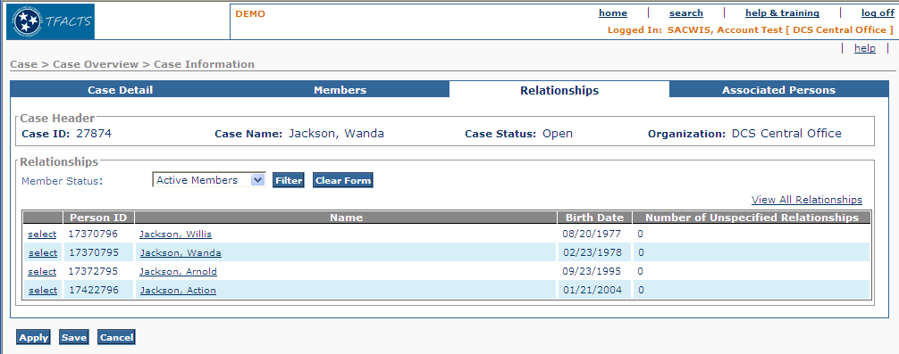
Figure 7 – As Is – Relationship Tab

To Be – Relationships Tab Mock Up
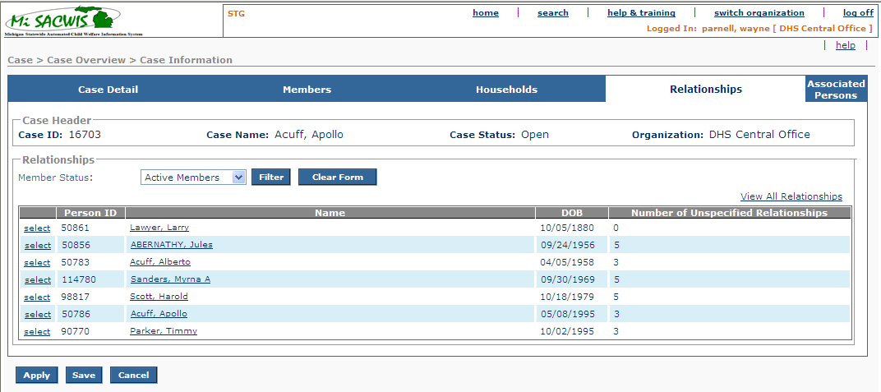

Figure 8 – To Be – Relationship Tab

Screen Fields for Relationship Screen (1 of 2)
Status (Unchanged/Add/Modify/Delete) | As Is  Class.Attribute Name | To Be  Class.Attribute Name | As Is  Display Name | To Be  Display Name | To Be  Type | To Be  Align | To Be Size | To Be  Read  Only | To Be  Calculation | To Be  Edit Mask | To Be  UI Validation
Keep | N/A | N/A | Case Header | Case Header | Section Header | L | N/A | T
Keep | CaseBase.caseID | CaseBase.caseID | Case ID | Case ID | Number | L | 22 | T
Keep | CaseBase.caseLastName + CaseBase.CaseSuffixNameCode  +CaseBase.caseFirstName + CaseBase.caseMiddleName | CaseBase.caseLastName + CaseBase.CaseSuffixNameCode  +CaseBase.caseFirstName + CaseBase.caseMiddleName | Case Name | Case Name | Display Text | C | N/A | T |  | Last name, first name, middle namecase reference person
Keep | CaseStatus.caseStatusCode | CaseStatus.caseStatusCode | Case Status | Case Status | Display Text | C | N/A | T | System derived from Case Status where CaseStatus.end_eff_date is null  Use short desc from Ref Data where domain code=’CaseStatus’
Keep | Agency.agencyName | Agency.agencyName | Organization | Organization | Text Field | R | 100 | T | System derived  From CaseAgencyLink.caseAgencyLinkId where end date is null
Keep | N/A | N/A | Relationship Grid | Relationships | Section Header | L | N/A | T
Keep |  |  | Member Status | Member Status | Drop Down List | L | 100 | T | Domain Code:  CaseParticipantStatus  Reference BR 3.5.5.5
Keep | CaseParticipant.personID | CaseParticipant.personID | Person ID | Person ID | Number | L | 22 | T
Keep | Use CaseParticipant.personID to get  Person.LastName + Person.suffixNameCode +Person.FirstName +Person.middleName | Use CaseParticipant.personID to get  Person.LastName + Person.suffixNameCode +Person.FirstName +Person.middleName | Name | Name | Hyperlink | L | N/A |  |  | Last name, x, first name middle name
Modify | Person.birthDate | Person.birthDate | Birth Date | DOB | Display Date | L | 10 | T | MM/DD/YYYY
Keep | N/A | N/A | Number of Unspecified Relationships | Number of Unspecified Relationships | Display Text | L |  | T |  | Calculated field based on the number of relationships equal to null for the selected person.

Action Buttons/Hyperlink
Status (Keep/Add/Modify/Delete) | Label | Type | On Click Action/Navigation
Keep | Filter | Button | Drop down box provides filtering options
Keep | Clear Form | Button | Clears filter
Keep | View All Relationships | Hyperlink | Executes CM03f-Maintain Relationship Summary
Keep | Select | Hyperlink | Executes CM03f-S01- Create/update scenarios
Keep | Name | Hyperlink | Execute PM01i – S01 in view mode

Business Rules
No. | Status (Keep/Add/Modify/Delete) | Business Rule Description | Modified Business Rule | Execution Event (field tab out/save etc) | Error Msg Code  To be completed by Development Team
1 | Keep | The agency organization to be displayed on the Relationships tab should be the current agency organization ‘case owner’ which is system derived from agency organization creating or reopening case; or agency organization to whom case has been transferred |  | At screen load or refresh
2 | Keep | Case name is displayed as Last Name, Suffix, First Name, Middle Initial (Lamb, Jr., Mary H.)  The case name always reflects the current Case Reference Person’s primary name in the order delineated above. |  | At screen load or refresh
3 | Keep | If the case is in open status, the status remains unchanged
4 | Keep | Names should display as First Last Name, Suffix, First Name Middle Initial, Last Name, Suffix for all names when in the Relationships tab/page
5 | Modify | The system should provide a filter to display relationship grid by ‘Active Members’, “Inactive Members’ or ‘All Members’ (in that order). The default view should be ‘Active Members’. | The system will provide a filter to display relationship grid by Case Participant Status of ‘Active Members’, “Inactive Members’, ‘Deceased’ or ‘All Members’ (in that order). The default view should be ‘Active Members’.
6 | Keep | When in an edit flow and the name hyperlink is clicked, the system shall present the user with a save and proceed confirmation message. |  | On Click of Name Hyperlink

Screen Navigation
No. | Status (Keep/Add/  Modify/Delete) | To Screen Navigation Path
1 | Keep | Navigate To relationship tab from the case details default page or CM03-S01, CM03-S02, CM03- S04

Pre-Conditions
No. | Status (Keep/Add/  Modify/Delete) | Pre-Condition
1 | Keep | Case ID must be in MiSACWIS

Reference Values
No. | Status (Keep/Add/  Modify/Delete) | To Be Class Attribute | Domain Code | Short Desc | Ref Data Code
1 | Add |  | CaseParticipantStatus | Active
 |  |  |  | Inactive
 |  |  |  | Deceased
 |  |  |  | All Members

Associated Persons Tab

As Is – Associated Persons Tab

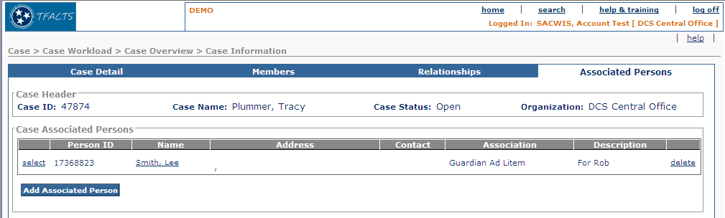

Figure 9 – As Is - Associated Persons Tab

To Be – Associated Persons Tab
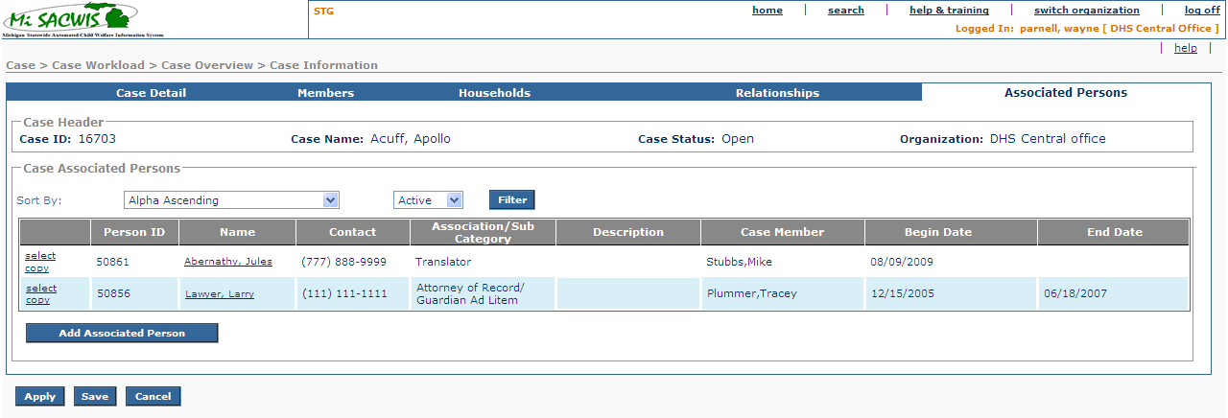
Figure 10 – To Be – Associated Persons Tab

Screen Fields
Status (Keep/  Add/  Modify/  Delete) | As Is  Class.Attribute Name | To Be  Class.Attribute Name | As Is  Display Name | To Be  Display Name | To Be  Type | To Be  Align | To Be Size | To Be  Read  Only | To Be  Calculation | To Be  Edit Mask | To Be  UI Validation
Keep | N/A | N/A | Case Header | Case Header | Section Header | L | N/A | T
Keep | CaseBase.caseID | CaseBase.caseID | Case ID | Case ID | Display Text | L | 20 | T
Keep | CaseBase.caseLastName + CaseBase.caseSuffixNameCode  +CaseBase.caseFirstName + CaseBase.caseMiddleName | CaseBase.caseLastName + CaseBase.caseSuffixNameCode  +CaseBase.caseFirstName + CaseBase.caseMiddleName | Case Name | Case Name | Display Text | C | N/A | T |  | Last name, suffix, first name, middle initial of case reference person
Keep | CaseStatus.caseStatusCode | CaseStatus.caseStatusCode | Case Status | Case Status | Text Field | C | N/A | T | System derived from Case Status where CaseStatus.end_eff_date is null  Use short desc from Ref Data where domain code=’CaseStatus’
Keep | Agency.agencyName | Agency.agencyName | Organization | Organization | Text Field | R | 100 | T | System derived  From CaseAgencyLink.caseAgencyLinkId where end date is null
Keep | N/A | N/A | Case Associated Persons | Case Associated Persons | Section Header | L | N/A | T
Keep | CaseAssociatedPerson.CaseAssociatedPersonId | CaseAssociatedPerson.personId | Person ID | Person ID | Number | L | 22 | T
Keep | Use  CaseAssociatedPerson.CaseAssociatedPersonId  to get  Person.LastName + Person.suffixNameCode +Person.FirstName +Person.middleName | Use  CaseAssociatedPerson.personId  to get  Person.LastName + Person.suffixNameCode +Person.FirstName +Person.middleName | Name | Name | Hyperlink | L | N/A | T |  | Last name, first name, middle name
Delete | Use CaseAssociatedPerson.CaseAssociatedPersonId  to get  Address.streetNbr + Address.preDirectionalCode + Address.streetName + Address.streetSuffixCode + Address.postDirectionalCode + Address.UnitNameCode + Address.UnitNumber + Address.CityName + Address.stateCode + Address.zip5Code + Address.zip4Code | + N/A | Address | N/A |  |  |  | T
Keep | PartyContactMedium.partyContact | PartyContactMedium.partyContact | Contact | Contact | Label | L | N/A | T | Use  CaseAssociatedPerson.CaseAssociatedPersonId
Modify | CaseAssociatedPerson.associationCode | CaseAssociatedPerson.associationCode | Association | Association/Sub Category | Display Text | L | 100 | T | Domain Code:  AssociationSubCategory
Keep | caseAssociatedPerson.otherAssociationDescText | caseAssociatedPerson.otherAssociationDescText | Description | Description | Display Text | L | 100 | T
Add | N/A | CaseAssociatedPerson.PersonID | N/A | Case Member | Display Text | L | 100 | T |  | Last name, first name, middle name
Add | N/A | CaseAssociatedPerson.BeginDate | N/A | Begin Date | Date  Field | L | 10 | T |  | MM/DD/YYYY
Add |  | CaseAssociatedPerson.EndDate | N/A | End Date | Date  Field | L | 10 | T |  | MM/DD/YYYY
Add | N/A | N/A | N/A | Sort By | Drop Down List | L | 100 | T | Use Domain Code =  AssociatedSortBy |  | See B.R.3.6.5.2 for the values to be populated
Add | N/A | N/A | N/A | Filter | Drop Down List | L | 100 | F | Use Domain Code: = CaseParticipantStatusType  See section 3.6.5.2 for BR |  | User Selected  See B.R. 3.6.5.3 for the values to be populated.

Action Buttons/Hyperlinks
Status (Keep/Add/Modify/Delete) | Label | Type | On Click Action/Navigation
Add | Filter |  | As described in 3.6.5
Keep | Select | Hyperlink | Hyperlink; launches the associated person details page with only the association and description fields enabled.
Add | Copy | Hyperlink | Hyperlink launches Associated Persons detail screen
Keep | Name | Hyperlink | Hyperlink launches PM01i-S01 in view mode; System derived; display only.
Delete | Delete | Hyperlink | Hyperlink; removes the selected person from the associated persons list.
Keep | Add Associated Person | Button | Button; launches CF54 – Find a Person

Business Rules
No. | Status (Keep/Add/  Modify/Delete) | Business Rule Description | Execution Event (field tab out/save etc) | Error Msg Code  To be completed by Development Team
1 | Modify | One record in grid for every Associated Person / Case Member combination
2 | Add | Filter drop down offers:  - Active  - Inactive  - All  Default filter is “Active”  “Inactive” are those Associations that have an End Date.
3 | Add | Sort default: Alpha ascending of Associated Person Last Name  Offer sort on Association Value (alpha ascending)
4 | Add | Copy function:  Copy: Association, Sub  Not: dates, members
5 | Add | Copy function cannot be used when Association = “Relative”.

Screen Navigation
No. | Status (Keep/Add/  Modify/Delete) | To Screen Navigation Path
1 | Keep | Navigate to Associated Persons from the Case Details page CM03-S01 or CM03-S02, CM03-S03

Pre-Conditions
No. | Status (Keep/Add/  Modify/Delete) | Pre-Condition
1 | Keep | Case ID must be in MiSACWIS

Reference Values
No. | Status (Keep/Add/  Modify/Delete) | To Be Class Attribute | Domain Code | Short Desc | Ref Data Code
1 | Add (sort) |  | AssociatedSortBy | Alpha Ascending | ALPHAASCENDING
 |  |  |  | Alpha descending | ALPHADESCENDING
 |  |  |  | Association | ASSOCIATION
 | Add (filter) |  | CaseParticipantStatusType | Active | ACTIVE
 |  |  |  | Inactive | INACTIVE

View Participation Status History

To Be – View Participation Status History
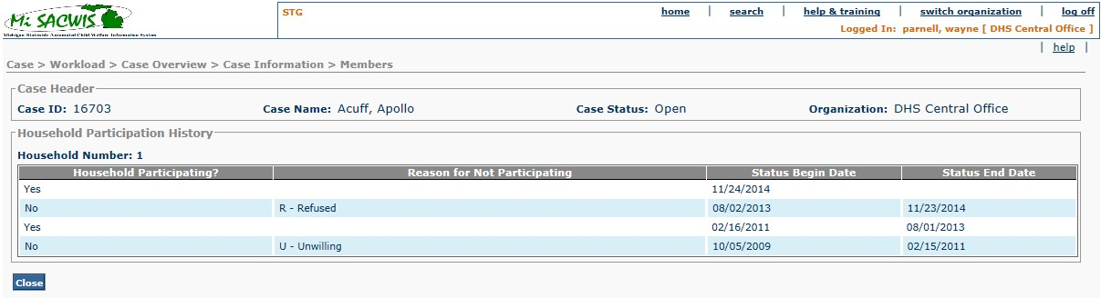

Screen Fields
Status (Keep/  Add/  Modify/  Delete) | As Is  Class.Attribute Name | To Be  Class.Attribute Name | As Is  Display Name | To Be  Display Name | To Be  Type | To Be  Align | To Be Size | To Be  Read  Only | To Be  Calculation | To Be  Edit Mask | To Be  UI Validation
Add | N/A | N/A | Case Header | Case Header | Section Header | L | N/A | T | N/A | N/A | See Case Header 3.1.3
Add | N/A | N/A | N/A | Household Participation History | Section Header | L | N/A | T | N/A | N/A | N/A
Add | N/A | HouseholdPrtStatus.householdID | N/A | Household Number | Number | L | 22 | T | N/A | N/A | N/A
Add | N/A | HouseholdPrtStatus.householdParticipatingCode | N/A | Household Participating? | Display Text | L | 100 | T | Domain code = YesNo | N/A | N/A
Add | N/A | HouseholdPrtStatus.reasonNoParticipationCode | N/A | Reason for Not Participating | Display Text | L | 100 | T | Domain code = ReasonForNotParticipating | N/A | N/A
Add | N/A | HouseholdPrtStatus.startDate | N/A | Status Begin Date | Display Date | L | 10 | T | MM/DD/YYYY | N/A | N/A
Add | N/A | HouseholdPrtStatus.endDate | N/A | Status End Date | Display Date | L | 10 | T | MM/DD/YYYY | N/A | N/A

Action Buttons/Hyperlinks
Status (Keep/Add/Modify/Delete) | Label | Type | On Click Action/Navigation
Add | Close | Button | Leaves S07 and returns to CM03 S04

Business Rules
No. | Status (Keep/Add/  Modify/Delete) | Business Rule Description | Execution Event (field tab out/save etc) | Error Msg Code  To be completed by Development Team
1 | Add | List ‘Household Participation Status’ records in order of most recent Start Date to oldest. | Page Load

Screen Navigation
No. | Status (Keep/Add/  Modify/Delete) | To Screen Navigation Path
1 | Add | Case > Case Overview > Households>View Participation Status History

Pre-Conditions
No. | Status (Keep/Add/  Modify/Delete) | Pre-Condition
1 | Keep | Case ID must be in MiSACWIS

Reference Values
No. | Status (Keep/Add/  Modify/Delete) | To Be Class Attribute | Domain Code | Short Desc | Ref Data Code
N/A | N/A | N/A | N/A | N/A | N/A
 |  |  |  | N/A | N/A
 |  |  |  | N/A | N/A
 |  |  |  | N/A | N/A

